

Open House Registry

Name: (Please Print) First Last

Present Address:

Best Phone #: ( ) - Email Address:

How did you learn about the open house?

O AD O Drive-by O Sign O Friend O MLS O My Agent

Do you know how Buyer Representation works? O Yes O No

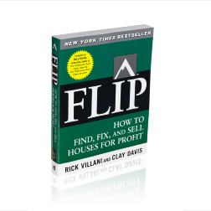

I want a FREE copy of FLIP! O Yes

O No

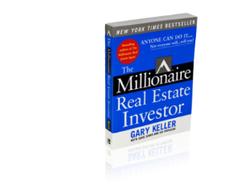

I want a FREE copy of Millionaire Real Estate Investor! O

Yes O No

Extra Comments:

Thank you for Visiting!